**Effect of Radius of sphere on falling speed in water**

03/06/2019

Ruiyan Huang

FP Physics 3

Jaime Gonzalez

**Introduction**

**Motivation**

Viscosity has been a useful tool with a lot of real-life applications. For example, in medicine, the viscosity of blood affects its transporting function, measuring the viscosity can help predict cardiovascular diseases. One such way to measure viscosity is falling ball method, which calculates the viscosity by the speed the ball travels. However, falling ball method is restricted only to high viscosity fluids. This experiment was performed to test how this method works in water and thus answer the research question of how radius of a sphere affects its falling speed in water.

**Theoretical background**

When an object is moving through a fluid, a force opposite the motion can be experienced known as Drag Force. There are three types of drag forces depending on different velocities an object moves at.

When an object moves through a fluid slowly, it experiences frictional drag. According to Stokes formula, for a sphere with radius R moving at speed v in a fluid with viscosity $η$, the frictional drag Ff can be expressed as

$$F_{f}=6πηRv$$

However, when an object is moving at higher speed, the fluid will be divided, forming a partially “vacuum” area at the back of the object. Farther fluid will move forward to fill this area, and thus creating turbulence. Pressure drag $F_{p}$ is thus produced due to the difference in pressure on two sides. (Drag of a Sphere) It can be calculated by:

$$F_{p}=C_{D}×\frac{1}{2}ρ_{f}v^{2}A$$

Where CD is drag coefficient, f is fluid density, v is velocity, A is reference area.

In the case of a sphere, the reference area A= $πR^{2}$, and thus

$$F_{p}=\frac{1}{2}C_{D}ρ_{f}v^{2}πR^{2}$$

Finally, there is a drag force called wave drag, which will not be considered in this experiment because wave drag can only occur for supersonic speed.

Beside drag forces, an object also experiences buoyancy while moving in a fluid. Specially, the buoyancy B in this experiment can be expressed as:

$$B=ρgV=ρ_{f}⋅g\frac{4}{3}πR^{3}$$

Meanwhile, the weight of the **s**phere with density $ρ_{S}$ is:

$W=ρ_{S}V=ρ_{S}⋅g\frac{4}{3}πR^{3}$,

Therefore, the net force a sphere experiences while falling through a fluid can be obtained by $F=W-F_{f}-F_{p}-B$. We can then know the terminal velocity, which, according to F=ma, can be obtained when net force equals zero:

$$F= W-F_{f}-F_{p}-B=0$$

$$ρ_{s}⋅g\frac{4}{3}πR^{3}-6πηRv-\frac{1}{2}C_{D}ρ_{f}v^{2}πR^{2}-ρ_{f}⋅g\frac{4}{3}πR^{3}=0$$

$$8\left(ρ_{s}-ρ_{f}\right)gR^{2}=36ηv+{3C}_{D}ρ_{f}v^{2}R$$

In order to solve the equation above, we need to know the value of $C_{D}$, which can be calculated by Reynolds number (Drag of a sphere), a non-dimensional number that represents fluid flow and can be calculated by

$$Re=\frac{ρνD}{η}=\frac{2Rρ_{f}⋅v}{η}$$

Where D is the length, which is the diameter 2R for a sphere.

According to the equation given by Allen flow (Unit 41),

$$C_{D}=\frac{18.5}{{Re}^{0.6}}=\frac{18.5}{{(\frac{2Rρ_{f}⋅v}{η})}^{0.6}}=\frac{18.5⋅η^{0.6}}{{\left(2Rρ_{f}⋅ν\right)}^{0.6}}$$

Therefore,

$$8\left(ρ_{s}-ρ_{f}\right)gR^{2}=36ηv+{3C}_{D}ρ_{f}v^{2}R$$

$$8\left(ρ_{s}-ρ_{f}\right)gR^{2}=36ηv+3*\frac{18.5⋅η^{0.6}}{{\left(2Rρ_{f}⋅ν\right)}^{0.6}}*ρ_{f}v^{2}R$$

$2^{3.6}{∙ρ_{f}^{0.6}(ρ_{s}-ρ_{f})g∙R}^{2.6}v^{0.6}=9*2^{2.6}∙ηρ_{f}^{0.6}∙R^{0.6}v^{1.6}+3*18.5η^{0.6}ρ_{f}v^{2}R$)

Thus, if all other values are known, velocity can be known by solving the equation above.

**Aim**

The primary aim is to investigate into the relationship between the radius of a sphere and its falling speed, and thus answer the research question of how radius affects falling speed;

The secondary aim is to work out a sphere of what radius should produce more satisfactory results.

**Hypothesis**

It is hypothesized that as the falling speed increase as the radius of a sphere increases, and spheres with lower radii are preferred because they travel slower in fluids, making the measurement more accurate.

**Methodology**

Materials and Apparatus

* Blu Tack
* Water
* an electronic balance ($±0.01g)$
* a ruler (15.00 $±$ 0.05cm)
* a beaker (2000 $±100$ mL)
* a graduated test tube (10 $±0.1$ mL)
* a clamp stand
* slow-motion camera (240fps)
* a piece of color paper

Variables

Independent variable: the radius of the sphere (by changing the volume of Blu Tack)

Dependent variable: the speed of falling of the sphere

Control variables:

|  |  |  |  |
| --- | --- | --- | --- |
| Variable | Significance | Method of control | Controlled value |
| The liquid the sphere falls through | Different liquids have different viscosity and density, which, according to the formula, influence falling speed. | Using water throughout the experiment. | Water $$ρ_{f}=1×{10}^{3}$$ $$kg/m^{3}$$ |
| The density of sphere | The density of the sphere is also a factor that influences the falling speed according to the formula. | Because the sphere is made by Blu Tack, the density varies, so the volume for every sphere is calculated and adjusted. | 1.80.1 g/cm3 |
| Water temperature | The water temperature can affect water’s density and viscosity and thus affect the falling speed. | The experiment was done at the same place as fast as possible so that there shall be less change in its temperature. | Around 10℃ |
| The distance the sphere travelled | The distance can affect speed because of acceleration. | The starting and finishing line was fixed so that every sphere will go through roughly equal distance. | 6cm |

Process

After preparing all the materials and apparatus needed, the 2000mL beaker was filled with an appropriate amount of water, so that it will not overflow when the sphere is put in. Mark the starting and finishing positions to be at 1200mL and 400mL, respectively, so that less acceleration and wall effect will be taken into account. Measure the distance between to be 6.00 $±0.05$ cm.

A small amount of Blu Tack was taken to make a sphere. To make sure the density remains the same throughout the experiment, the density was calculated using the formula $ρ=\frac{m}{V}$, where $ρ$ is density, m is mass and V is volume. The weight can be measured using the balance, and the volume can be obtained by the method of displacement in a test tube (10 $±0.1$ mL) (a tube was used because the volume is too small to be measured using measuring cylinders):

The tube was filled with an appropriate amount of water, with initial water volume V1. It is then leaned down so that water would not spill out when the sphere was put in. Fix the tube vertically on a clamp stand. Let the eyes be right before the bottom of the water surface and read the volume of water again to be V2. The volume of the sphere can thus be calculated by V=V2–V1.

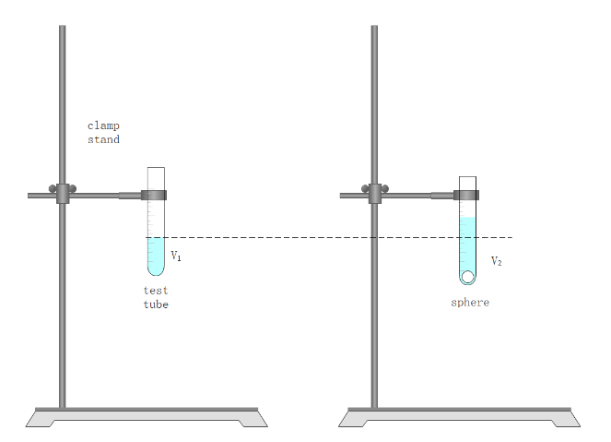

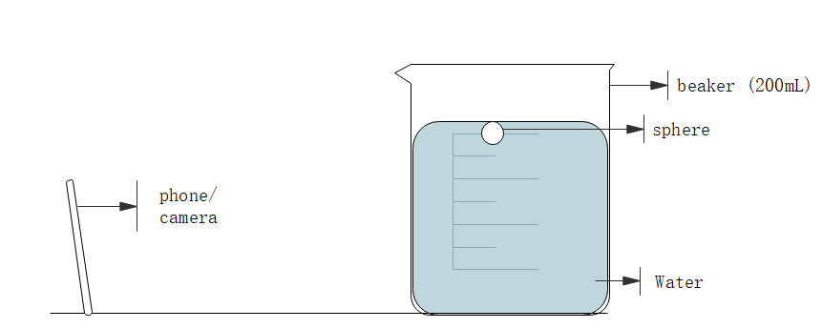

Figure 3. Measuring falling speed Figure 2. Method of displacement

Compare the densities of later sphere to this value, and adjust densities to be almost the same.

Now to measure the falling speed of the sphere in water, a piece of color paper should be first placed at the back of beaker so that the motion of sphere will be easier to be tracked in video analysis. Then, the phone is put at a fixed spot with a fixed angle. After all are prepared, hold the sphere right below water surface. Start the recording using slow-motion mode with 240fps, and release the sphere. When the sphere reaches the bottom, stop recording.

Repeat the same process for the same ball for three or more trials and record them.

Make 6 more spheres with different masses, calculate and adjust the densities, and repeat the experiment to measure the falling speed.

Raw Data

The videos were analysed using Tracker. Since it is not very accurate to track the sphere because the sphere is too big to be seen as a point mass, a better approach was taken to count the frame numbers. The starting frame (when the sphere reaches 1200mL) and finishing frame (when reaching 400mL) was recorded in the table below.

**Table 1. raw data for spheres**

|  |  |  |  |  |  |  |  |  |  |  |
| --- | --- | --- | --- | --- | --- | --- | --- | --- | --- | --- |
| **Experiment No.** | **1** | | | | **2** | | | |  |  |
| **volume(cm3)** | 0.3 | | | | 0.6 | | | |  |  |
| **Mass (g)** | 0.53 | | | | 1.06 | | | |  |  |
| **Trials** | 1 | 2 | 3 | 4 | 1 | 2 | 3 | 4 |  |  |
| **starting frame** | 144 | 189 | 193 | 327 | 405 | 106 | 75 | 484 |  |  |
| **finishing frame** | 189 | 238 | 238 | 372 | 448 | 150 | 118 | 526 |  |  |
| **distance travelled (cm)** | 6.00 | 6.00 | 6.00 | 6.00 | 6.00 | 6.00 | 6.00 | 6.00 |  |  |
|  |  |  |  |  |  |  |  |  |  |  |

|  |  |  |  |  |  |  |  |  |  |  |  |  |  |  |
| --- | --- | --- | --- | --- | --- | --- | --- | --- | --- | --- | --- | --- | --- | --- |
| **Experiment No.** | **3** | | | | **4** | | | | | **5** | | | | |
| **Volume (cm3)** | 0.9 | | | | 1.1 | | | | | 1.5 | | | | |
| **Mass (g)** | 1.64 | | | | 2.05 | | | | | 2.65 | | | | |
| **Trials** | 1 | 2 | 3 | 4 | | 1 | 2 | 3 | 4 | | 1 | 2 | | 3 |
| **starting frame** | 538 | 586 | 539 | 59 | | 194 | 1218 | 166 | 499 | | 329 | 312 | | 387 |
| **finishing frame** | 575 | 628 | 579 | 100 | | 233 | 1258 | 207 | 538 | | 369 | 348 | | 426 |
| **distance travelled (cm)** | 6.00 | 6.00 | 6.00 | 6.00 | | 6.00 | 6.00 | 6.00 | 6.00 | | 6.00 | 6.00 | | 6.00 |
|  |  |  |  |  | |  |  |  |  | |  |  | |  |
| **Experiment No.** | **6** | | | | 7 | | | | | | | | Uncertainty | | |
| **volume(cm3)** | 1.8 | | | | 2.1 | | | | | | | |  | | |
| **Mass (g)** | 3.20 | | | | 3.70 | | | | | | | | $±$ 0.01 | | |
| **Trials** | 1 | 2 | 3 | 4 | | 1 | 2 | 3 | 4 | | 5 | 6 | |  | |
| **starting frame** | 264 | 92 | 410 | 454 | | 360 | 232 | 333 | 476 | | 602 | 489 | | $±$ 1 | |
| **finishing frame** | 302 | 130 | 448 | 491 | | 395 | 262 | 369 | 515 | | 633 | 523 | | $±$ 1 | |
| **distance travelled (cm)** | 6.00 | 6.00 | 6.00 | 6.00 | | 6.00 | 6.00 | 6.00 | 6.00 | | 6.00 | 6.00 | | $±$ 0.05 | |

Data processing

Density for each sphere was first calculated and adjusted as shown in the table below:

**Table 2. data for properties of spheres**

|  |  |  |  |  |  |  |  |  |
| --- | --- | --- | --- | --- | --- | --- | --- | --- |
| Experiment No. | 1 | 2 | 3 | 4 | 5 | 6 | 7 | uncertainty |
| volume(cm3) | 0.3 | 0.6 | 0.9 | 1.1 | 1.5 | 1.8 | 2.1 | 0.1 |
| Radius (cm) | 0.42 | 0.52 | 0.60 | 0.64 | 0.71 | 0.76 | 0.79 | 0.01 |
| mass (g) | 0.53 | 1.06 | 1.64 | 2.05 | 2.65 | 3.20 | 3.70 | 0.01 |
| density (g/cm3) | 1.8  0.7 | 1.8 $$±0.3$$ | 1.8 $$±0.2$$ | 1.8 $$±0.2$$ | 1.8 $$±0.1$$ | 1.8 $$±0.1$$ | 1.8 $$±0.1$$ |  |

**Sampling calculation**

$$ρ=\frac{m}{v}=\frac{0.53}{0.3}≈1.8g/{cm}^{3}$$

$$∆ρ=\frac{ρmax-ρmin}{2}=\frac{\frac{0.54}{0.2}-\frac{0.52}{0.4}}{2}=0.7g/{cm}^{3}$$

By finding the difference between starting and falling frames, and knowing the camera is 240fps, we can use the ratio to calculate the times it takes.

After knowing time and distance, velocity can thus be calculated.

**Table 3. data for calculating average velocity**

|  |  |  |  |  |  |  |  |  |  |
| --- | --- | --- | --- | --- | --- | --- | --- | --- | --- |
| **Experiment No.** | **1** | | | | **2** | | | | |
| **Trials** | 1 | 2 | 3 | 4 | 1 | 2 | 3 | 4 |
| **starting frame** | 144 | 189 | 193 | 327 | 405 | 106 | 75 | 484 |
| **finishing frame** | 189 | 238 | 238 | 372 | 448 | 150 | 118 | 526 |
| **frame** | 45 | 49 | 45 | 45 | 43 | 44 | 43 | 42 |
| **time (s)** | 0.19 | 0.20 | 0.19 | 0.19 | 0.18 | 0.18 | 0.18 | 0.18 |
| **distance travelled (m)** | 0.06 | 0.06 | 0.06 | 0.06 | 0.06 | 0.06 | 0.06 | 0.06 |
| **velocity (m/s)** | 0.32 $±0.07$ | 0.29 $$±0.07$$ | 0.32 $$±0.07$$ | 0.32 $$±0.07$$ | 0.33 $$±0.07$$ | 0.33 $$±0.07$$ | 0.33 $$±0.07$$ | 0.34 $±0.07$ |
| **average velocity (m/s)** | 0.31 $±0.015$ | | | | 0.34 $±0.005$ | | | | |
|  |  |  |  |  |  |  |  |  |
| **Experiment No.** | **3** | | | | **4** | | | | |
| **Trials** | 1 | 2 | 3 | 4 | 1 | 2 | 3 | 4 |
| **starting frame** | 538 | 586 | 539 | 59 | 194 | 1218 | 166 | 499 |
| **finishing frame** | 575 | 628 | 579 | 100 | 233 | 1258 | 207 | 538 |
| **frame** | 37 | 42 | 40 | 41 | 39 | 40 | 41 | 39 |
| **time (s)** | 0.15 | 0.18 | 0.17 | 0.17 | 0.16 | 0.17 | 0.17 | 0.16 |
| **distance travelled (m)** | 0.06 | 0.06 | 0.06 | 0.06 | 0.06 | 0.06 | 0.06 | 0.06 |
| **velocity (m/s)** | 0.39 $$±0.09$$ | 0.34 $$±0.07$$ | 0.36 $$±0.08$$ | 0.35 $$±0.08$$ | 0.37 $$±0.08$$ | 0.36 $±0.08$ | 0.35 $$±0.08$$ | 0.37 $$±0.08$$ |
| **average velocity (m/s)** | 0.36 $±0.025$ | | | | 0.36 $±0.01$ | | | | |
|  |  |  |  |  |  |  |  |  |
| **Experiment No.** | **5** | | | **6** | | | |  |
| **Trials** | 1 | 2 | 3 | 1 | 2 | 3 | 4 |  |
| **starting frame** | 329 | 312 | 387 | 264 | 92 | 410 | 454 |  |
| **finishing frame** | 369 | 348 | 426 | 302 | 130 | 448 | 491 |  |
| **frame** | 40 | 36 | 39 | 38 | 38 | 38 | 37 |  |
| **time (s)** | 0.17 | 0.15 | 0.16 | 0.16 | 0.16 | 0.16 | 0.15 |  |
| **distance travelled (m)** | 0.06 | 0.06 | 0.06 | 0.06 | 0.06 | 0.06 | 0.06 |  |
| **velocity (m/s)** | 0.36 $$±0.08$$ | 0.40 $$±0.09$$ | 0.37 $$±0.08$$ | 0.38 $$±0.08$$ | 0.38 $$±0.08$$ | 0.38 $$±0.08$$ | 0.39 $$±0.09$$ |  |
| **average velocity (m/s)** | 0.38 $±0.02$ | | | 0.38 $±0.005$ | | | |  |
|  |  |  |  |  |  |  |  |  |
| **Experiment No.** | **7** | | | | | |  |  |
| **Trials** | 1 | 2 | 3 | 4 | 5 | 6 |  |  |
| **starting frame** | 360 | 232 | 333 | 476 | 602 | 489 |  |  |
| **finishing frame** | 395 | 262 | 369 | 515 | 633 | 523 |  |  |
| **frame** | 35 | 30 | 36 | 39 | 31 | 34 |  |  |
| **time (s)** | 0.15 | 0.13 | 0.15 | 0.16 | 0.13 | 0.14 |  |  |
| **distance travelled (m)** | 0.06 | 0.06 | 0.06 | 0.06 | 0.06 | 0.06 |  |  |
| **velocity (m/s)** | 0.41 $$±0.09$$ | 0.48 $$±0.1$$ | 0.40 $$±0.09$$ | 0.37 $$±0.08$$ | 0.46 $$±0.1$$ | 0.42 $$±0.1$$ |  |  |
| **average velocity (m/s)** | 0.425 $±0.055$ | | | | | |  |  |

**Sample calculation**

To calculate the frame:

$$frame=finishing-starting=189-144=45$$

To calculate the time:

$$time=\frac{frame}{fps}=\frac{45}{240}=0.19 s$$

To calculate the velocity:

$$v=\frac{s}{t}=\frac{0.06}{0.19}=0.32 m/s$$

$$∆v=\frac{vmax-vmin}{2}=\frac{\frac{0.07}{0.18}-\frac{0.05}{0.2}}{2}=0.07 m/s$$

**Table 4. data for comparing experimental and theoretical velocity**

|  |  |  |  |  |  |  |  |
| --- | --- | --- | --- | --- | --- | --- | --- |
| **Experiment** | **1** | **2** | **3** | **4** | **5** | **6** | **7** |
| **Radius (m)** | 0.00415 | 0.00523 | 0.00599 | 0.0064 | 0.0071 | 0.00755 | 0.00794 |
| **density (kg/m)** | 1.77E+03 | 1.77E+03 | 1.82E+03 | 1.86E+03 | 1.77E+03 | 1.78E+03 | 1.76E+03 |
| **density difference with water (kg/m)** | 7.7E+02 | 7.7E+02 | 8.2E+02 | 8.6E+02 | 7.7E+02 | 7.8E+02 | 7.6E+02 |
| **Average velocity (m/s)** | 0.30 | 0.31 | 0.35 | 0.34 | 0.37 | 0.38 | 0.41 |
| **Theoretical velocity (m/s)** | 0.30 | 0.39 | 0.49 | 0.55 | 0.57 | 0.62 | 0.65 |

**Figure 4. Effect of radius on experimental and theoretical falling speed**

The graph shows that both experimental and theoretical values of falling speed increase as the increase of radius. However, there is some inconsistence regarding the rate of increase. Even though the speeds for spheres with lower radii are in accordance, with percentage error of

$$percentage error=\frac{Exact-Approx}{Exact}×100\%=\frac{0.30-0.29}{0.29}=3.4\%$$

the results get much higher as the radii get larger, leading to a percentage error of

$$percentage error=\frac{0.65-0.41}{0.65}×100\%=36.9\%$$

**Sample calculation**

Knowing that=kg/m3; kg/m3; g=9.81ms-2; R=0.00415m; $η=1.3×{10}^{-2}$, the equation in introduction part is now solvable:

$2^{3.6}{∙ρ_{f}^{0.6}(ρ_{s}-ρ_{f})g∙R}^{2.6}v^{0.6}=9*2^{2.6}∙ηρ_{f}^{0.6}∙R^{0.6}v^{1.6}+3*18.5η^{0.6}ρ_{f}v^{2}R$)

$$2^{3.6}{∙{\left(1.00×{10}^{3}\right)}^{0.6}\left(0.77×{10}^{3}\right)×9.81∙\left(0.00415\right)}^{2.6}v^{0.6}$$

$$=9×2^{2.6}∙(1.3×{10}^{-2}){\left(1.00×{10}^{3}\right)}^{0.6}{\left(0.00415\right)}^{0.6}v^{1.6}+3×18.5⋅{\left(1.3×{10}^{-2}\right)}^{0.6}(1.00×{10}^{3})∙0.00415v^{2}$$

$$3.68900v^{0.6}=1.666067944v^{1.6}+17.01010879v^{2}$$

Using WolframAlpha to solve the equation:

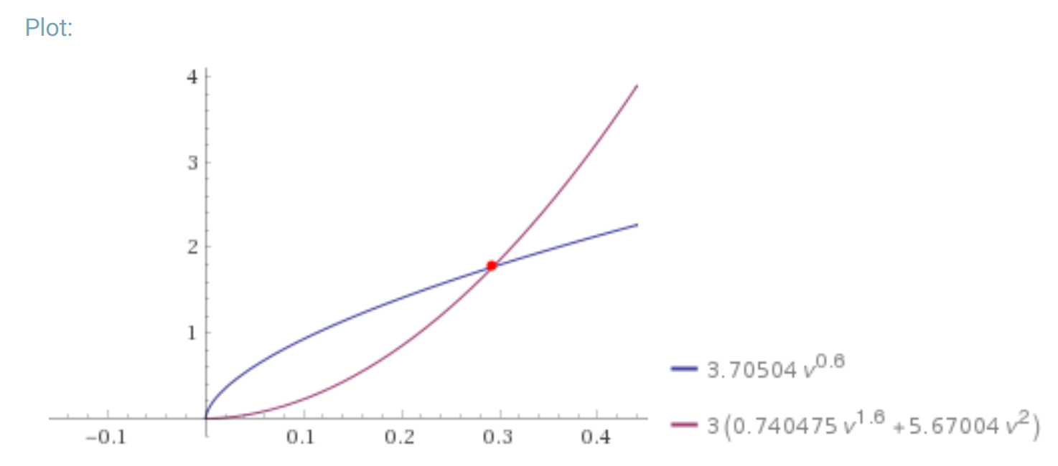

**Figure 5. the solution to the equation (WolframAlpha)**

v $≈0.30$

**Conclusion and evaluation**

**Results & evaluation**

The result confirms the hypothesis that as the radius of a sphere increases, its falling speed through water increases as well. However, there is a discrepancy between the theoretical and experimental value.

The discrepancy may exist in both experimental and theoretical values.

First, the experimental results can be influence by the value of distance and time.

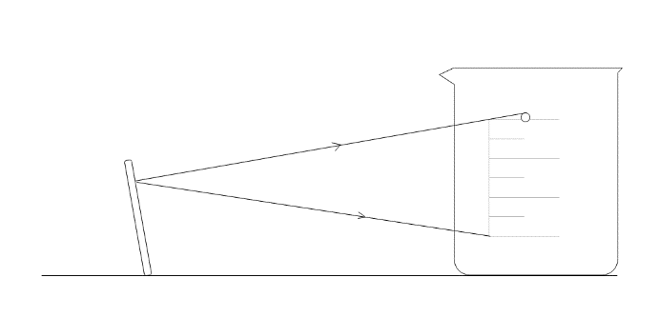The time measured was not precise enough because of systematic error. The camera was a point light source, so the line of sight is unparallel to the starting and finishing lines. As figure 6 shows, it began recording before the sphere reaches the starting line and also stop recording later. Thus, the measured time is longer, so the velocity calculated is less than the real value. Improvement could be made by putting two cameras right in front of the two lines and record the motion simultaneously.

**figure 6.**

**The effect of unparallel line of sight**

Neither is the distance precisely measured. When the sphere is falling through water, it was not falling vertically down because of its rotation in the water that causes frictions in different directions, which contributes to the lower velocity in the result.

Also, systematic error exist that the calculated values are not terminal speeds because of the limitation of apparatus. Even though the starting line was set as low as possible, most of the values measured include the acceleration. Moreover, when radius increases, pressure drag increases exponentially and frictional drag increases linearly, by applying Newton’s second law $F=ma$, acceleration also increases, meaning that as radii increase, the experimental values include increasingly more acceleration instead of terminal velocity. That also provides an explanation why the discrepancy gets increasingly bigger when radii increase. Improvements can be proposed by using: deeper container and thus longer travelling distance, sphere and fluid with smaller density differences, higher fluid viscosity, etc.

Second, the theoretical values are also not precise.

The volume, and thus radius and density, of sphere was measured imprecisely with random errors. Even though the test tube is the most precise apparatus available in lab with minimum scale is 0.2mL, it is still relatively large in terms of the volume of the sphere, and thus makes the measuring of radius difficult; Also, even though the volume of every sphere was measured and adjusted, the density could change every time it was taken out and reshaped a bit after each trial. Alternatively, hollow metallic balls or a fluid with higher viscosity can be used, so that the volume is easier to be measured by using Vernier caliper since the volume is always fixed.

Also, viscosity changes because of wall effect. The sphere sometimes does not travel vertically down and gets closer to the wall of beaker. However, the viscosity is different because fluids closer to walls are less movable, resulting more friction between layers and thus larger viscosity and slower falling speed. In order to solve this issue, higher and wider container shall be used so that the spheres have enough space and time to reach their terminal velocities; longer distance helps diminish small errors by having a larger total value; wider containers helps the sphere to stay further away from the wall and thus reduce wall effect.

**Conclusion**

In conclusion, larger radii lead to larger falling speed of a sphere through water. Also, spheres with smaller radii and thus slower falling speed leads to higher accuracy of the result. Thus, spheres with appropriately smaller radii are preferred when conducting falling ball experiment. However, the rest experimental values still differ a lot from the theoretical ones. A lot more needs to be taken into consideration while applying theoretical knowledge into practice and performing an experiment in real life.

**Works cited**

“Alpha: Making the World's Knowledge Computable.” Wolfram, www.wolframalpha.com/.

“Drag of a Sphere.” NASA, NASA, [www.grc.nasa.gov/www/k-12/airplane/dragsphere.html](http://www.grc.nasa.gov/www/k-12/airplane/dragsphere.html).

“Unit 41: Fluid Mechanics.” Freestudy, [www.freestudy.co.uk/fluid%20mechanics%20h1/outcome34.pdf](http://www.freestudy.co.uk/fluid%20mechanics%20h1/outcome34.pdf).